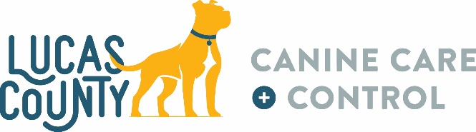
WISH LIST
- Wire crates (new or gently used)
- Hills Science Diet adult, puppy, and small breed dry dog food
- Canned dog food (any brand, flavor, type)
- American cheese slices
- Soft dog treats
- Large & XL slow feeder bowls
- Puppy pads
- Waterless shampoo
- Large & XL Kong stuffable toys for extreme chewers
- Nylabone/Benebone type chew toys
- Stuffed toys (new or gently used)
- Outdoor toys (new or gently used)
- Small plastic pools (new or gently used)
- Fleece blankets (new or gently used)
- Pig ears
- Bully sticks
- Oatmeal dog shampoo & conditioner
- Enrichment making items (paper towel tubes, paper lunch bags, cheerios, cheese crackers, catnip)
- Gift cards (pet stores, Amazon, home improvement stores, grocery stores, gas cards)
- K9 Ballistics Chew Proof Armored Vinyl Elevated Dog Bed (https://surl.lu/iwaifd)
- Kuranda dog beds (visit www.kuranda.com/donate and select Lucas County Canine Care & Control)
We, and the dogs, appreciate anything you can give!

1301 Monroe St
Toledo, Ohio 43604
419-213-2800
lucascountydogs.com
Monday – Friday 11am to 6pm
Saturday & Sunday 11am to 5pm

